**MANAGING PATIENT CONSENT FORM—“OPT OUT”**

After performing the search, click anywhere on the row with the patient’s name to begin.

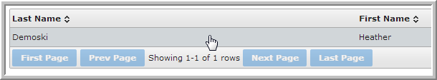

After selecting the **Consent** tab, you will see the patient’s data sharing status set to either **Opt In** or **Opt Out**. This setting can only be changed by a Clerk or Administrator.

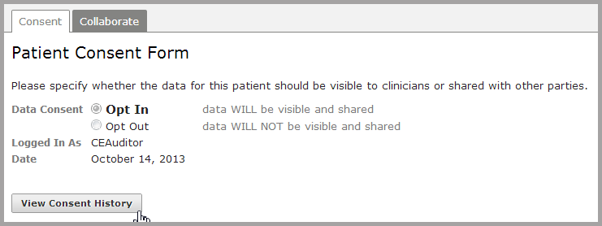

Note: the default setting for *Data Consent* on the Patient Consent Form is set to **Opt In**. This is the default for an HIE that follows an opt-out consent model: all information not specially protected by federal or state laws is shareable under HIPAA TPO provisions and will be shared unless a patient explicitly elects to opt out of the system.